Create a Spring Web Project using Maven

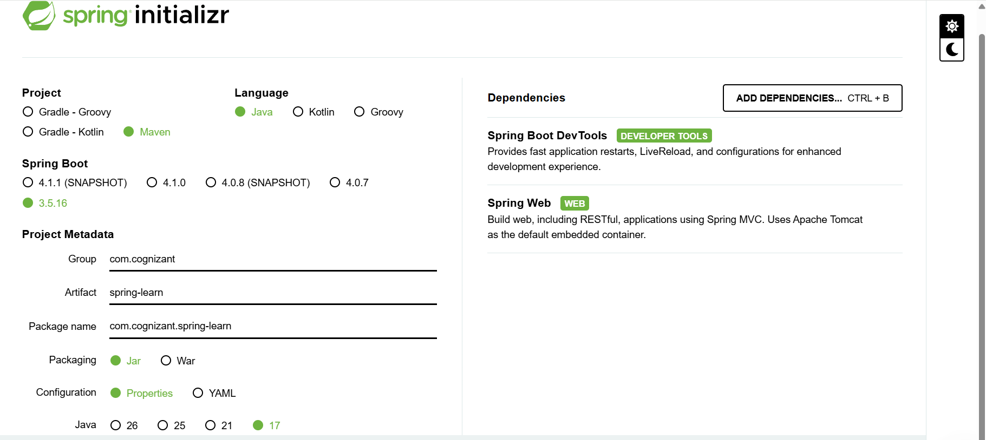

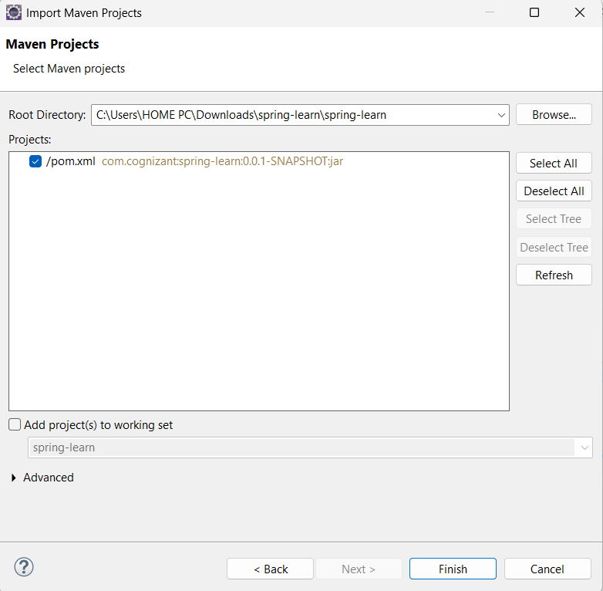
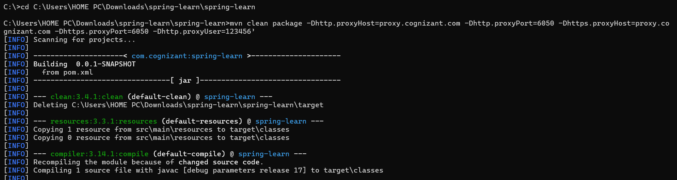
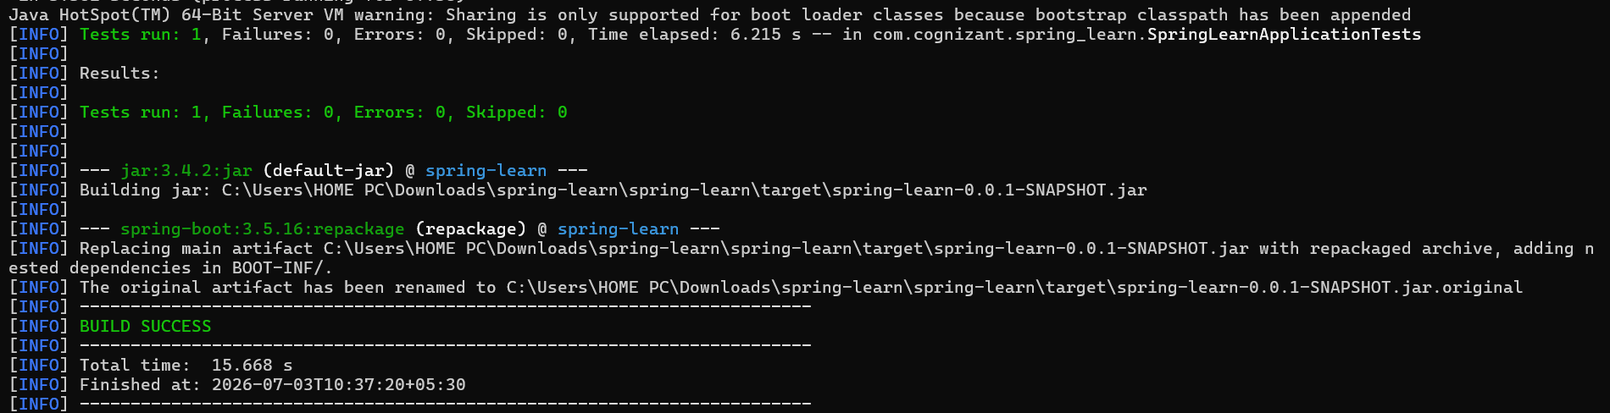

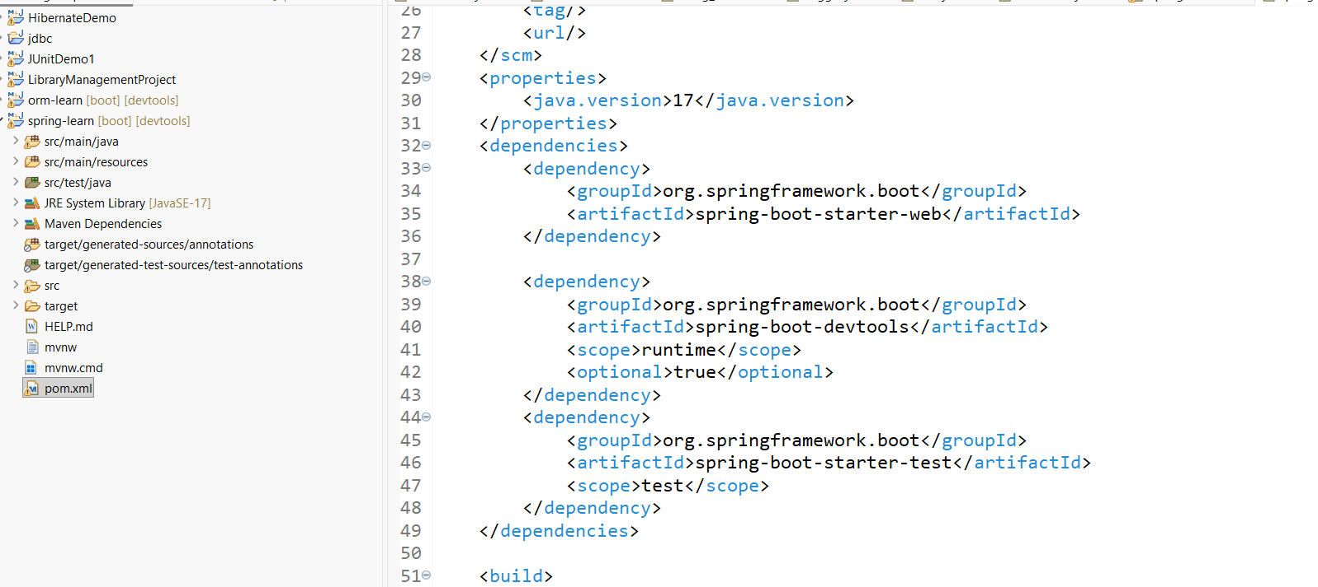
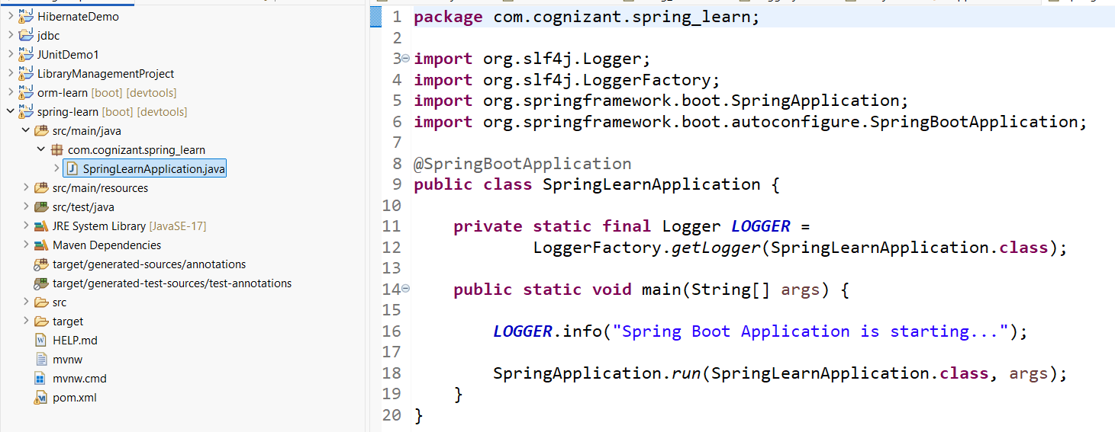

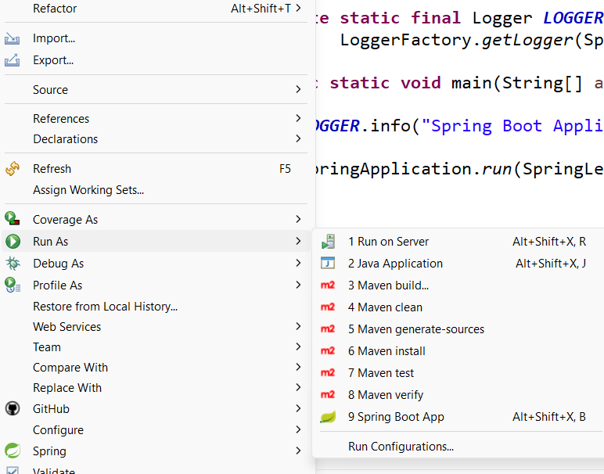

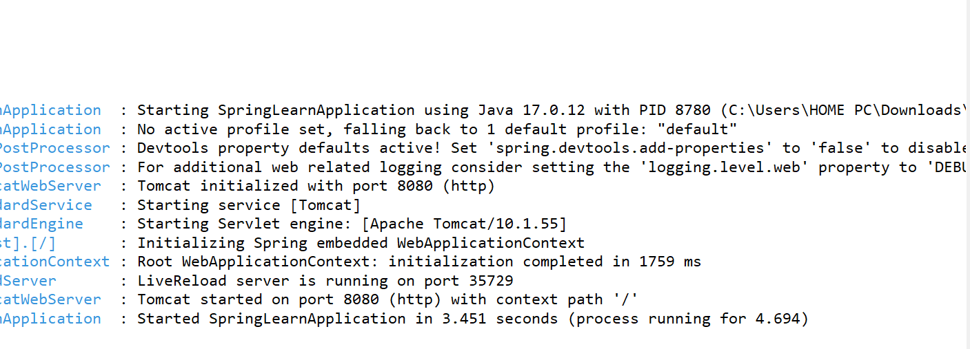

SME to walk through
src/main/java - Folder with application code
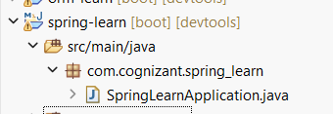

src/main/resources - Folder for application configuration
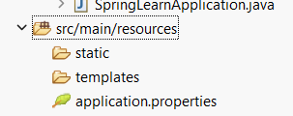
src/test/java - Folder with code for testing the application
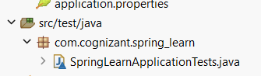

SpringLearnApplication.java - Walkthrough the main() method.
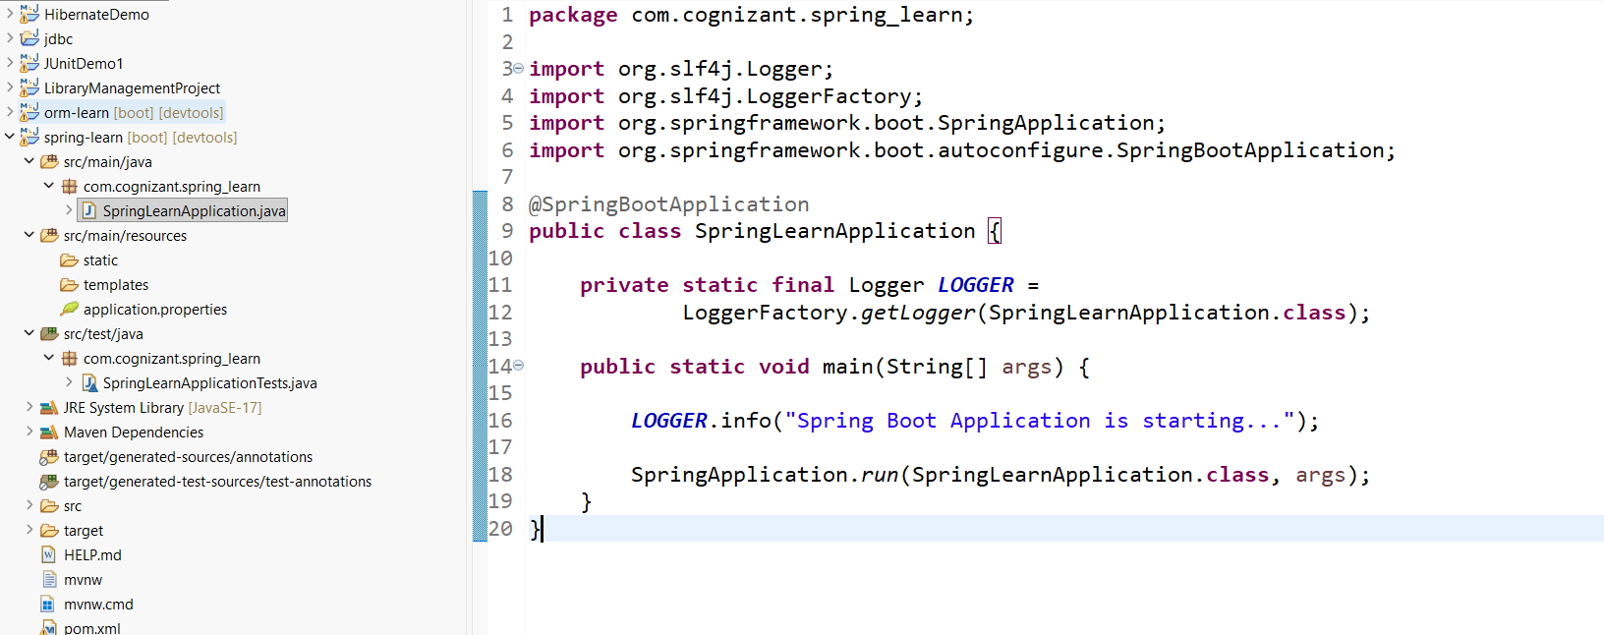

Purpose of @SpringBootApplication annotation
@SpringBootApplication is the main annotation used in a Spring Boot application. It tells Spring Boot to start and configure the application automatically.
It is a combination of three annotations:
- @Configuration – Indicates that the class contains Spring configuration.
- @EnableAutoConfiguration – Automatically configures the application based on the dependencies present in the project.
- @ComponentScan – Scans the current package and its sub-packages to detect Spring components such as @Controller, @Service, @Repository, and @Component.
Purpose:
- Marks the main class of the Spring Boot application.
- Enables auto-configuration.
- Scans and registers Spring components.
- Simplifies configuration by combining three annotations into one.
pom.xml
The pom.xml (Project Object Model) is the configuration file of a Maven project. It contains the project information, dependencies, plugins, Java version, and build configurations required to build and run the Spring Boot application.
Walkthrough of the Configuration Defined in pom.xml
- Project Coordinates
  - groupId – Specifies the organization or package name (com.cognizant).
  - artifactId – Specifies the project name (spring-learn).
  - version – Specifies the current version of the project.
- Parent Configuration
  - spring-boot-starter-parent is used as the parent project.
  - It provides dependency management, default plugin configuration, and compatible versions of Spring Boot libraries.
- Properties
  - Specifies the Java version used for the project (Java 17).
- Dependencies
  - Spring Boot Starter Web – Provides the libraries required to develop web and REST applications, including Spring MVC and the embedded Tomcat server.
  - Spring Boot DevTools – Provides development-time features such as automatic application restart.
  - Spring Boot Starter Test – Provides libraries required for testing Spring Boot applications using JUnit and Mockito.
- Build Plugin
  - spring-boot-maven-plugin is used to package and run the Spring Boot application using Maven.
Dependency Hierarchy
The Dependency Hierarchy displays all the libraries required by the project. It consists of:
- Direct Dependencies – Dependencies explicitly added in the pom.xml file.
- Transitive Dependencies – Additional libraries automatically downloaded by Maven because they are required by the direct dependencies.
For example, adding the spring-boot-starter-web dependency automatically downloads several supporting libraries such as Spring MVC, Spring Core, Spring Context, Embedded Tomcat, Jackson, and Logging libraries.
The Dependency Hierarchy can be viewed in Eclipse by opening the pom.xml file and selecting the Dependency Hierarchy tab. It helps developers understand the dependency tree, identify transitive dependencies, and resolve dependency conflicts.

